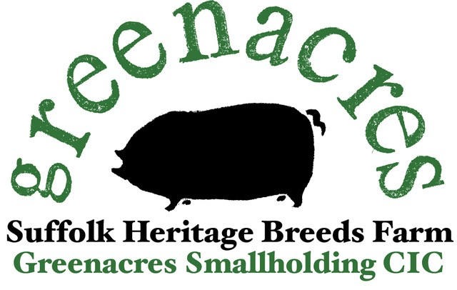

Our Vision
- To create a safe, sustainable, biodiverse space for all people, animals, and nature to learn, grow and thrive.

- To provide an alternative, sustainable way for people to source their food direct from the farm in a way that is fair for consumers and farmers alike.
- To address food poverty by giving people the tools to become self-sufficient.
- To maintain and sustain the Suffolk Heritage Breeds for future generations.

What have we achieved so far?
- Over the past 8 years, in our spare time, we have been gradually clearing the rubbish from the site, re-instating and managing the boundary hedgerows, building corridors for nature and wildlife.

- From 2017 - 2021, we successfully managed, bred, and produced a small herd of free-range, mixed, native breed pigs, successfully selling the produce on Farmers Markets throughout Suffolk, and building a small but loyal following amongst our customers.

- Through the sale of our produce, we have re-invested in more livestock, namely Ixworth chickens and Silver Appleyard ducks. In October 2021, with the help of our members and directors we were able to purchase 3 Suffolk ewes. And in 2022 we were donated a pair of Red Poll cows, mother and daughter.

- We are listed as a private nature reserve (PNR) with the Suffolk Wildlife Trust, and have been actively encouraging a wildflower meadow, by grazing the livestock over winter.

- In 2021, we were successful in a bid for 420 saplings to celebrate the Queens Green Canopy. We also received a donation of trees from Mr. Templeman.

- In March 2024 we received 1100 trees from the Woodland Trust to reinstate boundaries and shelter belts around the farm. That planting is on-going and in December 2024 we had an additional 100 trees through the Woodland Trust East Suffolk Clayland’s scheme.
.
- In 2021 we set up a Community Interest Company, a special type of company that is not-for-profit and benefits the community that it serves, rather than directors and shareholders.

- We continue to reduce our reliance on using heavy machinery to carry out daily tasks, such as feeding livestock.

- In 2023 we welcomed the first school visits with The Country Trust Charity. Last year we welcomed just short of 200 children to the farm to learn about farming and where their food comes from. This year we expect to welcome Year 1 students from 2 schools in Ipswich and 1 school in Stowmarket.

- We continue to sell our produce on Ipswich Market, on Friday and in March this year we accepted a pitch on a Saturday, both are making a small profit and providing an income to the farm. Enabling people from Ipswich and the surrounding areas to support local farms in Suffolk.

- Paul Storey became a director of the company in January of this year and is developing the market garden area of the smallholding. By using No-Dig techniques and Soil Food Web principles, he is focusing on regeneration of the soil, in order to produce the best possible produce, without the use of chemicals or artificial fertilisers.

Our Local Connection and how we can support our Community

Andrew’s family farm was part of Witnesham village from the 17th century.
Bought by his great-grandfather in 1906, the family farmed for 4 generations before the sale in 2009. Many local people will have bought directly from Nelson Farm throughout the generations and will have memories of Andrew’s family and the farm.
By re-creating the farmyard as it was in the 1887 land survey, we will be able to offer a living history of Witnesham village life as it would have been in the 1930’s. Bringing revenue, volunteering, training, and job opportunities, as well as raising the profile of the villages we serve.
This will develop to be an educational and therapeutic immersive experience for all people of all ages to learn, grow and thrive.
We believe that our smallholding can help to sustain the villages, by providing fresh, locally grown, seasonal vegetables, fruit, meat, eggs, and dairy, direct from the farm at realistic prices, and feed those who are struggling to make ends meet.
We recognize that we still have a long way to go to achieve all our dreams and ambitions for our little corner of the Suffolk Countryside
And we can’t do all this on our own, so we are asking for Community Investment from householders in the villages.
By investing in the farm, either financially, or physically, together, we can create
“A farm owned by the community,
for the benefit of the community.”

